

**I’m Brave Going Back to School**

**NAME:**

There are a lot of changes happening now at school and at home.

It may make me feel a bit worried, a lot worried, or not at all worried.

I might be unable to hug my friends like I used to, make TikTok videos together, or share kicks with our favourite ball.

We may even have to sit apart at school, talk from a distance and not be able to hangout after school too.

Instead, now we will chat via Zoom or wave to each other from afar.

In these new times don’t forget to be kind to yourself and to each other.

Physical distancing and hand washing will help keep us safe and life will become more normal soon.

(HH aged 10)

Kia ora  
This booklet is yours to complete however you like. You are welcome to draw on it, colour it in or add your own ideas and artwork to it. You may like to complete the booklet with your caregiver or share it with your teacher or another trusted adult at school. We encourage parents/caregivers to read through the tip sheet ‘Supporting Children Returning to School’ on [www.manaake.health.nz](http://www.manaake.health.nz) to support the ideas outlined in this booklet.

For more information about getting ready to go back to school, and general wellbeing advice, parents/caregivers can visit these websites:

* <https://www.theparentingplace.com/>
* [www.sparklers.org.nz/parenting/](http://www.sparklers.org.nz/parenting/)
* [www.allright.org.nz](http://www.allright.org.nz)
* <https://www.anxietycanada.com/>
* <https://www.brainline.org/article/brainstars-regulation-emotion>

To talk to a trained counsellor free call:

* 0800 What’s up
* 1737

For more wellbeing activities, check out these websites:

* <https://biglifejournal.com/pages/podcast>
* <https://www.awesomeendsin.me/product-category/free-printables/>
* <https://www.whatsup.co.nz/>
* <https://www.heysigmund.com/video-library-home-page/>

Phone apps to support using mindfulness and daily wellbeing:

* Smiling Minds
* Go Noodle
* Headspace
* Settle your glitter

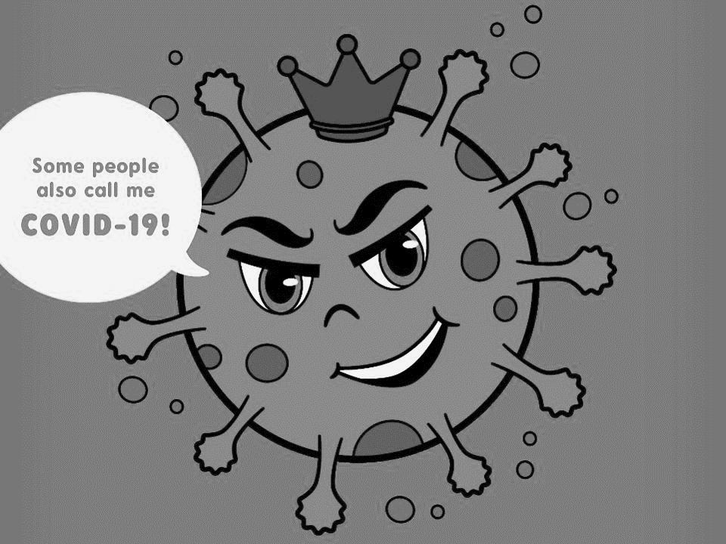

In March 2020, the world started changing due to a virus called COVID- 19 aka Coronavirus.

In an effort to keep New Zealanders safe and healthy the Prime Minister, Jacinda Ardern announced an alert level system.

At alert level 2, we had already noticed some changes happening with sports events and social activities starting to get cancelled.

On the 25th March New Zealand went into alert level 4. This meant that we had to stay home to reduce the risk of spreading the virus, to keep not only ourselves but our extended family, friends and community members safe.

While we were in level 4 we were not able to go to school for a while. The holidays started early and when term 2 started we were completing our school work in different ways.

For some people this meant completing work that was sent to their homes and for others it meant doing school work online or joining their class through video calling.



During the lockdown we stayed in our own “bubbles”.

Draw the people who were in your bubble:

Going into level 4 lockdown is something that we have never had to do before. Some people liked it, some people didn’t. How did it feel for you?

Unscramble the emotion words below, then draw a line to the matching unscrambled word.

1. Rowdier Tired
2. Denyano Confused
3. Fondcues Creative
4. Pyhpa Entertained
5. Cactiset Worried
6. Tertaineden Bored
7. Creedcon Happy
8. Redit Over it
9. Vaunetdomit Ecstatic
10. Dativetom Unmotivated
11. Rivetace Motivated
12. Debor Concerned
13. Rove ti Annoyed

Ka pai hoki koutou! Good on you New Zealand we have done SUCH a good job at staying at home and our Prime Minister, Jacinda is so proud of us! The Prime Minister and her team will tell us when we can go back to school.

 

When we go back to school we will still be safe. We will get to see some of our teachers and friends again and keep learning about all of our favourite subjects, like maths, science, social studies and English!

There might be some new measures or changes in place when we return to school to help keep us safe.

We can prepare for changes by:

remembering our school values and using a growth mindset to keep thinking positively and with focus.

It is important that we continue helping to keep everyone healthy by stopping bugs from spreading. We can do this by washing our hands regularly, trying to not touch our faces, sneezing and coughing into our elbows and limiting physical touch.



Throughout the day we touch lots of things such as doors, desks, books and our phones so it is important to wash our hands particularly before and after eating and after going to the toilet.



When I think about going back to school I feel: (write below or draw your emotion on the face)



However you are feeling, it’s okay.

Here are some of the things I think will be different about school: (write or draw below)

Here are some of the things I think will be the same: (write or draw below)

Here are some things I will miss about learning at home: (write or draw below)

These are the things I am most looking forward to once I go back to school: (write or draw below).

When you feel worried or uncertain there are some strategies you can use to help you feel calmer. It is important to start by practicing using these when you already feel calm. Try out the ideas below!





Choose several of the categories below, give yourself 5 minutes to come up with as many items as you can for each category.

|  |  |  |  |
| --- | --- | --- | --- |
| Movies | Books | Places you want to visit | Breakfast food |
| Famous people | Words beginning with B | Cars | TV Shows |
| People in your class | Cities | Sports | Things you see in nature |

Here are some ideas of discrete things you can do at any time or place that can help take your mind off uncomfortable thoughts/feelings.

* Name all the things you can see around you that are a specific colour e.g. blue.
* Count backwards from 100 in 7s.
* Say the alphabet backwards starting with Z.
* Name as many different toys you can think of.
* Think of a meaningful memory for every letter of the alphabet.
* Write a list of places you would travel to if money was no object.
* Choose an object that you can see, describe it to yourself with as much detail as possible.
* Create your own emoji.
* Name as many characters you can from your favourite book or movie.
* Name all your family members, their ages and one of their favourite activities.

**Here is a plan to help me get back to school!**

When I’m feeling __________ I can:

(Tick the options you think would help)

* Take 5 deep breaths
* Imagine my favourite place
* Focus on 5 things I can see, 4 things I can hear, 3 things I can smell, 2 things I can feel, 1 thing I can taste
* Talk to my teacher about how I am feeling
* Talk to my parent/caregiver about how I am feeling
* Talk to my friends about how I am feeling
* Tell yourself to be brave and that you can do this
* Write your feelings down
* Write a list of things that make you smile
* Practice using distraction techniques

Here are some of my own ideas of things I could try:

**The Future**

Many people are upset about the changes caused by the coronavirus. But with all of us working together, in time things will settle down and get back to normal again. In times like this, it’s really helpful to make plans to look forward to in the future.

Draw a picture of something you are looking forward to in the future.

