Nau mai haere mai

A great big Kia Ora Koutou and especially to those who have joined Ngā Manu Āwhina Cluster 8 over term 1. We hope that despite the ongoing pandemic demands you have had a good start to the year and we look forward to continuing to work alongside you to support you to meet the needs of your students, teachers, schools and our cluster community at all tier levels. We especially look forward to more kanohi ki te kanohi over the next terms. This email is just a brief reminder re upcoming events and initiatives.

Upcoming Events

Cluster 8 Events and Workshops

All in our Cluster 8 school community are welcome to attend our workshops and events: - Principals, DPs/APs, SENCo, LSC colleagues, Kāhui Ako across and in-school teachers, other specialist and school staff and RTLBs. The 2022 learning and networking workshop and event days are usually from 9am to 3pm on:
· Term 2: 17 May 9am to 3.30pm Strengthening the Learning Support Community Event: Mahia te Mahi. Venue: Royal Oak Primary Hall
· Term 2: Tuesday 21 June
· Term 3: Tuesday 6 September.
STRENGTHENING THE LEARNING SUPPORT COMMUNITY: MAHIA TE MAHI
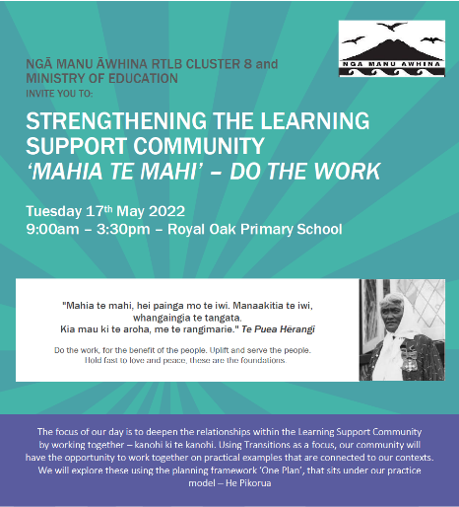
As mentioned previously, you really do not want to miss this rescheduled event as we come together with all in our learning support community. This is your opportunity to add your voice, hopes and dreams to the kōrero about how we work together to meet the needs of our learners and to share best practice. At this event we will be using the He Pikorua Framework to explore the relationships and roles of people in our cluster learning support community. We will be looking at examples and together applying our own understandings and strengths to a series of practical scenarios. He Pikorua is the one practice framework for all practitioners who work across learning support guiding our practices so we can work together to provide a coherent approach. There is less focus on criteria, and more on joined up services and one plan to support mokopuna and the adults around them in ways that build on strengths. Please email pamw@rops.school.nz to register by the 11th of May.
Collaboration and Support Hub Drop In

A reminder that our 3 RTLB hubs: Royal Oak Primary, Tāmaki College and Ōrākei School have termly Collaboration and Support Drop In mornings from 10 am to 1pm so that RTLB, DPs, SENCos, MoE LS, teachers and LSCs are able to kōrero, inquire, collaborate, provide support and guidance, access and share expertise and tiered project work. This is a great opportunity to network, so even if you can just pop in for 10 minutes over lunch or morning tea breaks, we would love to see you.

- Term 2: May 25th Royal Oak, May 26th Tāmaki, May 27th Ōrākei
- Term 3: August 31st Royal Oak, September 1st Tāmaki, September 2nd Ōrākei
- Term 4: End of year thank you morning tea: - November 30th Royal Oak, December 1st Tāmaki, December 2nd Ōrākei.

Other Training and Workshops

- Face-to-Face and E- Workshops will be added to the website as they are confirmed.
· 24th May An Introduction to Zones of Regulation - register with Tracey Richardson traceyr@rtlbcluster8.ac.nz
· 8 June Mediated Learning - register with Sandi Sebestian sandis@rtlbcluster8.ac.nz.
- Assessment Training
  - Cognitive Assessment System—CAS2 Brief training. This has been rescheduled to a later date. Expressions of interest to Barbara Hannant barbarah@rtlbcluster8.ac.nz.
- Database Training
  - Training is available for those who are new to requesting support through the Cluster 8 database and also sessions for those who would like a refresher or assistance. Please direct any queries to Angelee Morrow angeleem@rtlbcluster8.ac.nz.
- You can register for IYT Incredible Years Teacher by contacting Sue Cameron suec@rtlbcluster8.ac.nz. There is the possibility of Incredible Years Autism and/or Incredible Years Parent sessions later in the year, please contact Sue if you are interested in these possibilities.

Some Cluster 8 Initiatives
There are a number of RTLB initiatives running across the cluster where we welcome your queries and/or involvement. These include:-
- Kāhui Ako Support, MoE LS and LSC Collaboration in conjunction with support from our RTLB Practice/Partnership Leaders
- Social Emotional Learning (SEL) Support, Wellbeing and Resilience Programmes
- Mentoring and Coaching Support
- Heath and Education Collaboration
- ASD Support
- Play Based Learning Group
- Foundation Skills for Learning
- Mathematics Community of Practice Workshops
- Early Intervention Programme
- Behaviour Initiatives including Escalation Profiles
- Secondary Community of Practice
- Early Intervention Programme (EIP)
- Feuerstein Instrumental Enrichment (FIE)
- Gateway and Vulnerable Children Support
- Bilingual Assessment (BAS)

Please talk with your liaison RTLB or click on the ‘connect’ link on the website if you wish to know more about or to link into any of the above initiatives.

The RTLB Team

This term we are fortunate to have welcomed four fully experienced and trained RTLB: - Sarah Pearce, Mark Larkin, Wendy Florence and Donna Southworth. We would also like to thank Debbie Saxon for the work she has done over the last year.

It was with great sadness and sincere sympathies to the family that we acknowledged the passing of Margaret Muir RTLB (and former RTLB Practice Leader) on 12 March 2022. Margaret has left a huge educational legacy and her light will continue to live on in the work she did and the expertise she shared.

Check Out the Website and Thank You

The Cluster 8 website provides information and showcases what the cluster and RTLB can offer in tiered individual and systemic support, and professional development to our cluster also providing access to a range of resources. A key contact person for specific support (for e.g., ASD, dyslexia etc) is listed and there is the opportunity for MoE, RTLB and our cluster’s teachers to engage in a community of practice in areas of expertise and interest. Project leads and ‘Connect’ people can be located and are accessible for additional support on the connect tab. This is just a brief update, the full termly Manager’s reports are available here.

We are grateful for the opportunity to work alongside you to meet the needs of our students, teachers, schools and cluster community. Thank you for your collegiality and willingness to be responsive to different and innovative ways of working during change. As always, it continues to be a pleasure to work with so many dedicated, innovative and responsive professionals and whānau. We hope you enjoy a very well-deserved school break.

Ngā mihi nui

Roseanne and Cluster 8: Ngā Manu Āwhina RTLB

Te mahi ngātahi i te whakatutukitanga o ngā tumanako me ngā moemoea
Together weaving the realisation of hopes and dreams

Roseanne Gibson | Cluster 8 Manager | Reg Psychologist
Ngā Manu Āwhina RTLB Cluster 8
Website: https://www.rtlbcluster8.ac.nz
Office +64 9 624 2800 Mobile +64 21 966119
Royal Oak School, 7 Chandler Ave, Auckland 1023

